- 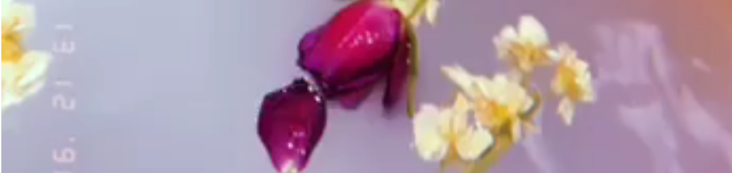So in this bit the flowers will be the banner and this will link directly to the music video as the flowers and water show the ending shot of the music video hence why the album cover will also be flowers. This shows cross media convergence between the music video and the album cover and the website.

- 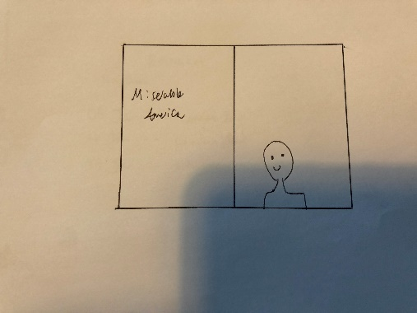I will create a full replicated Genius interview which gives “behind the scenes” meanings of the lyrics. I will also edit this intro to replicate the Genius Interview vibe to the max. This will hopefully show some good cross media convergence.

Social media feeds
I will have a whole social media bar with multiple links to different websites which all work and I will even have a link to warner group who are linked with the artist
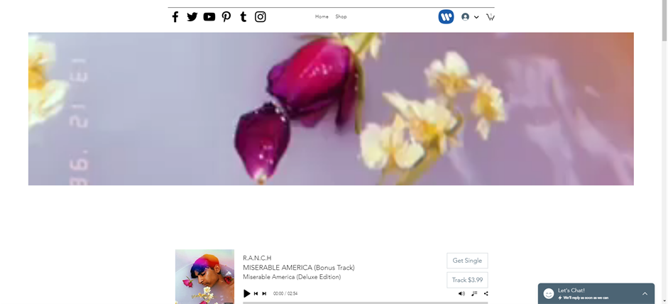
Band/artist Bio
I will have a whole section dedicated to R.A.N.C.H which includes the titles “BIO” and “About R.A.N.CH”. In this it says “R.A.N.C.H is a 22 year old singer and song writer based in London. However, he grew up in the US and realised the social inequalities in todays society being part of a smaller ethnic group.
R.A.N.C.H believes in Black Lives Matter and fortunately has signed a deal with Warner Music and therefore can put across the world with his new hit Miserable America
He strongly believes that in todays society we aren't allowed to express our opinions and bases his music to raise awareness and protest the issues of today” This greatly backs up the idea of protest songs and what the examiners are asking for. I will even further develop this by adding a Black Lives Matter link which leads to the official page to make my work that extra bit better.

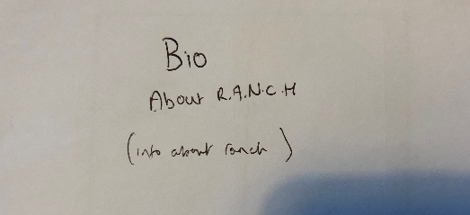
Original photos
I will have many original photos

- I have not only created an original album cover art I put thought into this to show cross media convergence as it links with the video
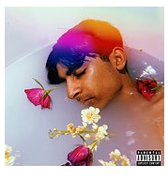
- I will create a custom thumbnail to go with the website theme
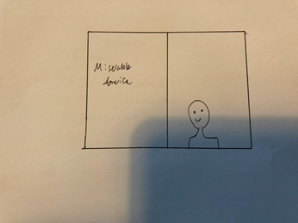

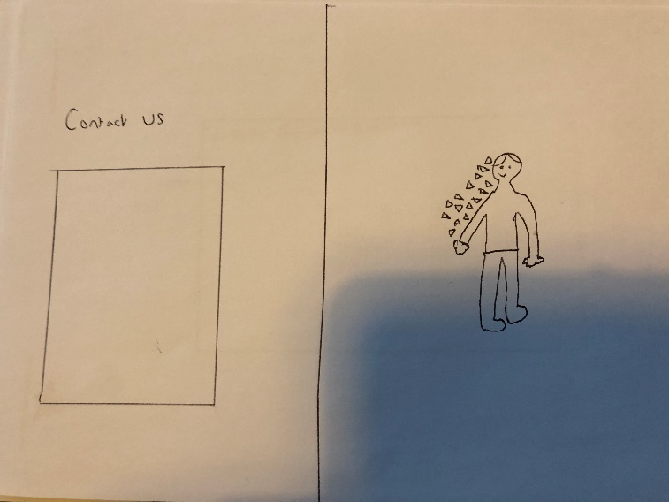
- This greatly links to my website and music video as 1. It will be black and white which goes with my whole website and music video as my video is black and white and this isn’t for no reason this is because the black and white is meant to represent that the world is dull, and we have no hope unless we change our ideals as a society. If this wasn’t enough, I felt I could go even further by editing the photo to make it a live photo by making fragments of my body in the photo constantly come off of me. Again, this was for a reason I did this as it is meant to show R.A.N.C.H is fading away and he is losing himself due to society and how it works.

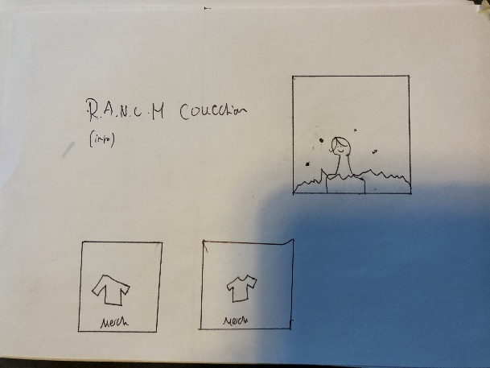
- I felt this was still not enough for original photos, so I decided I will complete a promo photoshoot for the merch. In which I will edit to make flames and ambers fly across the screen in a loop this is because it is the society collection this keeps a house style as it links with the video about society burning but it also links to the merch as they have R.A.N.C.H’s logo to make it more personal as R.A.N.C.H’s logo shows society burning and how it is not functioning correctly. This use of editing is special in the sense that it moves but also stays still.

Video Prototype
The final product will be on the website but also embedded as a YouTube video. I will also embed the Genius interview within the website as well.
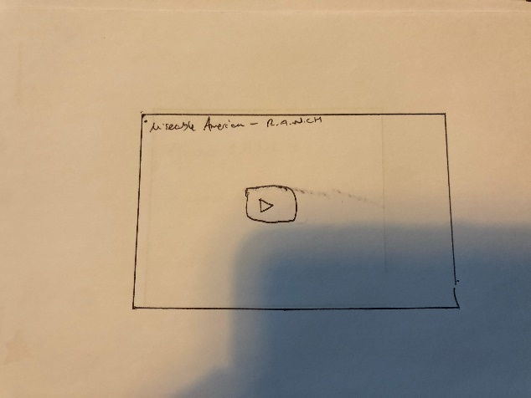

News about artist, a tour, etc.
I felt news about the artist wasn’t relevant as I already produced a bio about R.A.N.C.H and Instead I will place tour dates about R.A.N.C.H, The tour isn’t just random it has meaning behind it the tour will be a London tour as R.A.N.C.H is based in London and as an artist he loves London so therefore this keeps a consistent brand image and this will make R.A.N.CH more believable . Furthermore, I will add a competition which is another interactive element which offers tickets to the London tour. 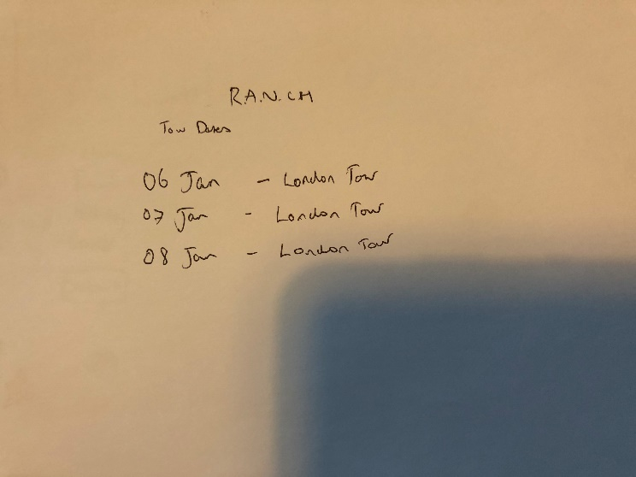

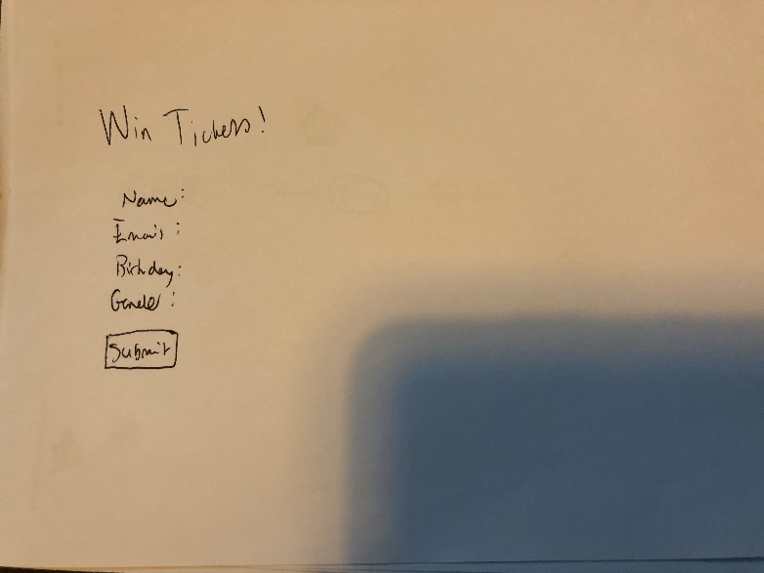

“The merchandise
There will be a second page and there will be a direct link labelled as “shop” in the taskbar which leads to the merchandise page.

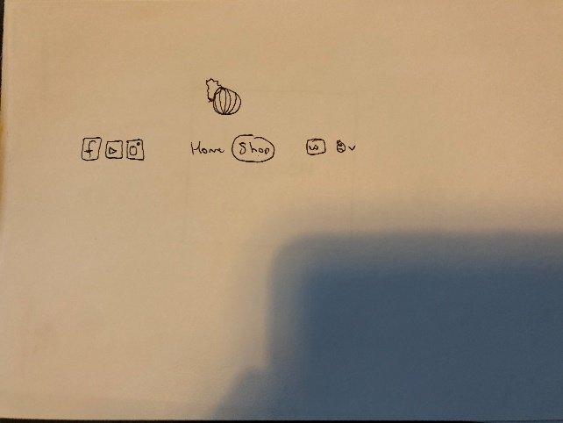
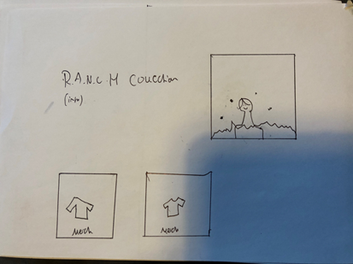

House Style
The house style will be very consistent. Firstly, I will go with a black and white theme as it links to my video and shows how the world is so dull and boring. I will add black borders around the media to keep a consistent house theme and also make the media fit in better.

Extra functions
I feel I can make this a really good website that has many features within it and these are some extra features I will add to make it that slight bit better.
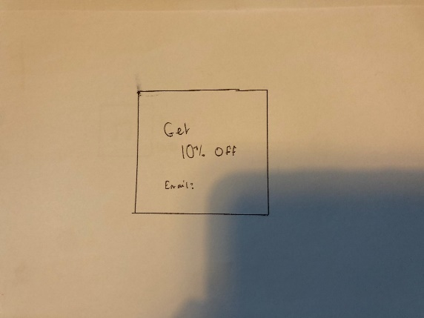
This will be a lightbox that is for a promo of 10% off merchandise if they subscribe to the website and this will also be in black and white to keep the house theme.
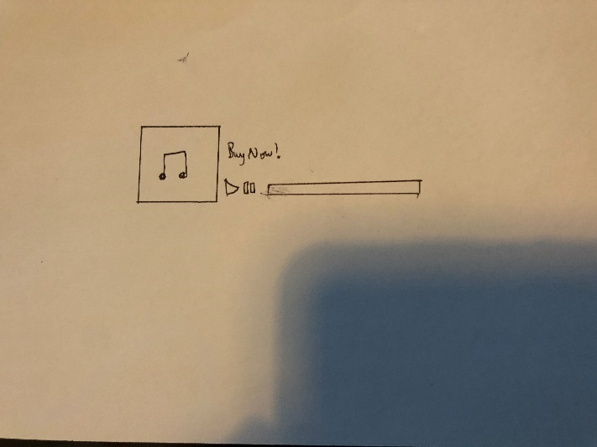
I will add a working music player which actually has the song uploaded to the website in which you can play it live there and then on the website.
I will add fade transitions to everything on the website to make it seem more professional and sleek but to also represent that fading theme of the music video and idea that society is making R.A.N.C.Hs character fade away.

